Week 5 - Week commencing 28/2/2022

**Week Outline**

Online meeting discussing the next steps of the project, calculating a power emitted by the background as a blackbody. Starting from the filter profiles of the detector, the filter profiles essentially acts as a “transmission” factor for a range of frequency ranges. These filter profiles were combined and given as data, plotted as shown:

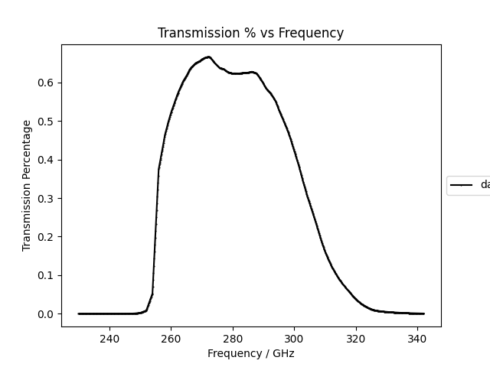

This gives the overall power that is filterered away and can be multiplied with the power to give the received power by the detector.

The next step is to calculate the integral for the blackbody function over the filter bandwidth. We can model the background as a blackbody at temperature T measured in week 1 and by integrating over the bandwidth, gives us the power/solid angle.

Finally, we can multiply this power/solid angle with $λ^{2}$ as the antenna throughput and obtain the power received by the detector from the room.

**Complete Python Code Attached at the End of Diary**

**Tasks Outline**

* Workout the Full-width-half-maximum of the filter profile and take the midpoint of it as the frequency $v$
* Workout $dv$ as the final frequency point – first frequency point of the filter profile
* Create a Planck Function, use the temperature T of the room and frequency range as the inputs and integrate over the Planck Function over the first and last value of the frequency of the filter profile.
* Use this value and multiply by the transmission profile to get the filtered power/solid angle
* Finally, use this value and multiply by the throughput of the “antenna” $λ^{2}$ which is the midpoint frequency $v$ converted to wavelength to get power received by the detector.

**Transmission Profile with FWHM and Midpoint**

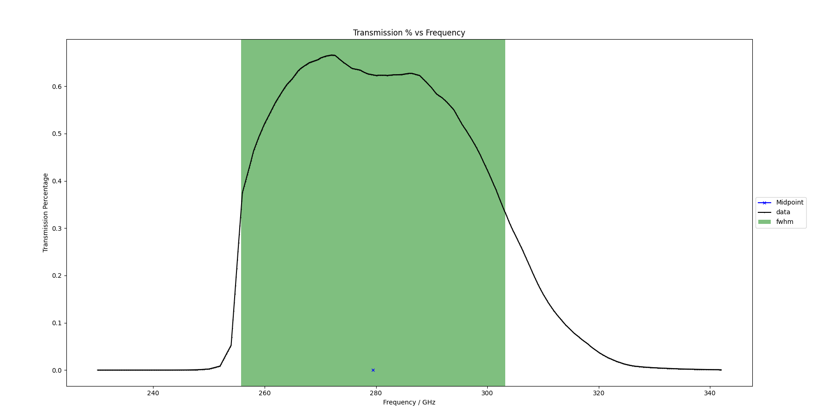

Green bar = FWHM

Blue cross = midpoint

**Results**

Power received by the detector emitted by room at 293K over the filter profile bandwidth:

$$P = 2.430 ×{10}^{-10} W$$

Or

$$P = 243 pW$$

**Distinction between the NEP and NET**

Following from previously, we have calculated a NET based on detector data and the response. The NET gives a good description for the system as a whole, but the NEP gives a better description for th detector as NET does not consider the optical bandwidth but the NEP does.

A good way to think about it is to imagine a thermal camera. A thermal camera typically has a large bandwidth. Thus, this allows it to have a higher sensitivity to temperature gradients, e.g. low NET. However, having such a large bandwidth essentially “masks” the detector, as larger bandwidths means allowing for more noise to saturate the data, thus increasing the NEP. The NEP gives a better description of the fundamental limit of the detector when compared to the photon noise.